**NGO Management**

**Abstract**

NGOs (Non-Governmental Organizations) play a vital role in addressing social, economic, and environmental challenges worldwide. Efficient management of these organizations is crucial for maximizing their impact and ensuring sustainable outcomes. This abstract presents an innovative NGO Management System designed to streamline operations, enhance transparency, and facilitate collaboration among stakeholders.

The NGO Management System integrates comprehensive functionalities to address the diverse needs of NGOs, including project management, donor management, volunteer coordination, and impact assessment. Key features include a centralized dashboard for real-time monitoring of projects and resources, automated reporting tools for accountability and compliance, and secure data management to safeguard sensitive information.

Through the adoption of advanced technologies such as cloud computing, data analytics, and mobile accessibility, the system empowers NGOs to optimize resource allocation, identify areas for improvement, and scale their initiatives effectively. Moreover, the platform facilitates communication and knowledge sharing among staff, volunteers, donors, and beneficiaries, fostering a collaborative ecosystem conducive to innovation and impact.

By leveraging the capabilities of the NGO Management System, organizations can enhance their operational efficiency, increase stakeholder engagement, and ultimately drive positive social change. The system's user-friendly interface and customizable features ensure adaptability to the unique requirements of different NGOs, making it a valuable asset for the sector as a whole.

In summary, the NGO Management System represents a significant advancement in organizational management technology, offering a holistic solution to the challenges faced by NGOs in today's complex landscape. By empowering organizations with the tools they need to succeed, the system contributes to building a more resilient and impactful civil society worldwide.

**CHAPTER 1**

**Introduction**

Managing finances effectively is paramount for the success and sustainability of non-governmental organizations (NGOs). A comprehensive NGO management system for financial management is essential to ensure transparency, accountability, and efficient utilization of resources. This system encompasses various tools and processes designed to streamline financial operations, facilitate reporting and analysis, and support decision-making to advance the organization's mission.

Key Components of an NGO Management System for Financial Management:

**Budgeting and Planning:** The system should enable NGOs to create, monitor, and adjust budgets for various projects, programs, and organizational expenses. It should support detailed budgeting processes, allowing for allocation of funds to specific activities and monitoring of expenditures against budgeted amounts.

**Income Management:** Efficient management of income involves tracking donations, grants, fundraising proceeds, and other sources of revenue. The system should provide tools for recording and categorizing income, issuing receipts and acknowledgments, and reconciling income with donor records.

**Expense Tracking and Management:** Managing expenses encompasses recording, categorizing, and monitoring all expenditures incurred by the organization. The system should facilitate expense approval workflows, track payment disbursements, and enable expense reconciliation with budget allocations.

**Financial Reporting:** Generating accurate and timely financial reports is crucial for stakeholders to assess the organization's financial health and performance. The system should offer customizable reporting templates for balance sheets, income statements, cash flow statements, and other financial metrics, catering to the needs of internal management, donors, and regulatory authorities.

**Donor Management and Relationship Tracking:** Maintaining strong relationships with donors is essential for sustaining funding and support. The system should provide donor management functionalities, including donor profiles, communication histories, and preferences tracking, to personalize engagement and stewardship efforts.

**Grant Management:** For NGOs reliant on grants, managing grant funds effectively is critical. The system should support grant proposal development, tracking of grant disbursements and expenses, compliance monitoring, and reporting to grantors.

**Audit Trail and Compliance**: Ensuring compliance with regulatory requirements and donor restrictions is imperative for maintaining trust and credibility. The system should maintain a comprehensive audit trail of financial transactions, user activities, and compliance documentation to facilitate internal and external audits.

**Integration with Accounting Software:** Seamless integration with accounting software streamlines financial data management and reduces manual data entry errors. The system should support integration with popular accounting platforms, enabling seamless transfer of data for reconciliation, reporting, and analysis.

**Security and Data Privacy:** Protecting financial data from unauthorized access and breaches is paramount. The system should employ robust security measures, including data encryption, access controls, and regular security audits, to safeguard sensitive financial information.

**Capacity Building and Training:** Providing training and capacity-building opportunities for staff and volunteers enhances their financial management skills and promotes compliance with established policies and procedures.

Benefits of an NGO Management System for Financial Management:

**Enhanced Transparency:** Providing stakeholders with access to accurate and up-to-date financial information fosters transparency and accountability, strengthening trust and confidence in the organization.

**Improved Decision-Making:** Access to real-time financial data and reporting tools enables informed decision-making, allowing NGOs to allocate resources strategically and prioritize initiatives that align with their mission and goals.

**Streamlined Operations:** Automation of financial processes and workflows reduces administrative burden, minimizes errors, and increases operational efficiency, allowing staff to focus on core mission activities.

**Compliance and Risk Management:** Implementing robust controls and monitoring mechanisms ensures compliance with regulatory requirements and reduces the risk of financial mismanagement, fraud, and misuse of funds.

**Optimized Resource Allocation:** By gaining insights into funding sources, expenditure patterns, and program effectiveness, NGOs can optimize resource allocation, directing funds towards initiatives with the greatest impact.

**Stakeholder Engagement:** Providing donors, board members, and other stakeholders with access to financial reports and performance metrics enhances engagement and fosters a sense of ownership and accountability.

In conclusion, an NGO management system for financial management plays a vital role in ensuring the fiscal health, sustainability, and effectiveness of non-profit organizations. By leveraging technology, best practices, and robust processes, NGOs can streamline financial operations, enhance transparency, and maximize the impact of their mission-driven initiatives.

**Module Description**

The Financial Management Module within the NGO management system serves as the cornerstone for effective fiscal oversight and transparency. It offers a comprehensive suite of tools and functionalities designed to streamline financial operations, ensuring compliance, and providing stakeholders with accurate and timely financial information. This module enables NGOs to efficiently manage budgets, track income and expenses, generate detailed financial reports, and facilitate donor and grant management. Through features like budgeting and planning, income and expense tracking, and donor management, NGOs can optimize resource allocation, maintain financial accountability, and enhance stakeholder trust. Integration with accounting software ensures seamless data synchronization, while robust security measures safeguard sensitive financial information. By promoting transparency, facilitating informed decision-making, and fostering a culture of financial stewardship, the Financial Management Module empowers NGOs to maximize the impact of their mission-driven initiatives and drive positive change in their communities.

The Financial Management Module represents the backbone of financial governance within NGOs, offering a suite of tools and functionalities tailored to their unique needs. With an emphasis on budgeting, NGOs can meticulously plan and monitor their financial resources, ensuring alignment with organizational goals and programmatic objectives. Income management features enable NGOs to accurately record and categorize diverse revenue streams, from individual donations to institutional grants, fostering transparency and accountability in financial reporting.

Expense tracking functionalities empower NGOs to monitor expenditures closely, ensuring that resources are allocated efficiently and in accordance with donor intentions and organizational priorities. By providing robust reporting capabilities, the module enables NGOs to communicate their financial performance effectively to stakeholders, from board members to donors and regulatory bodies, fostering trust and confidence in the organization's stewardship of funds.

Moreover, the module's integration with accounting software streamlines data management processes, reducing manual errors and enhancing the accuracy of financial records. This integration not only facilitates seamless reconciliation but also ensures compliance with accounting standards and regulatory requirements.

In summary, the Financial Management Module is indispensable for NGOs seeking to uphold the highest standards of financial governance, transparency, and accountability. By leveraging its comprehensive functionalities, NGOs can optimize resource utilization, minimize risks, and drive sustainable impact in their communities, thereby advancing their mission and vision with confidence and integrity.

**Chapter 2**

**System Specigication**

### Software Requirements

|  |  |  |
| --- | --- | --- |
| Operating System | : | Windows 10& above |
| Simulator Tool | : | VS 17.7.6 |
| Programming Language  **Hardware Requirements** | : | Javascritt,VITEjs |
| Processor | : | Intel core i3(min) |
| RAM | : | Minimum 4 GB and Recommended 8 GB |
| Hard Disk | : | 24 GB to accommodate the project files, datasets, and software tools |
| Input Device | : | Standard Keyboard and Mouse |
| Output Device | : | Standard Monitor |

**System Tools**

Visual Studio Code is a fast and efficient source code editor available for Windows, Mac OS X, and Linux on your PC. Together with a strong ecosystem of extensions for additional languages and runtimes (such as C++, C#, Java, Python, PHP, Go, and.NET), it comes with built-in support for JavaScript, TypeScript, and Node.js. Using the Electron Framework, Microsoft created the source code editor Visual Studio Code, or VS Code, for Windows, Linux, and macOS. Embedded Git, snippets, intelligent code completion, debugging support, and syntax highlighting are a few of the features.

**CHAPTER 3**

**SYSTEM ANALYSIS**

**Existing System**

The existing systems for NGO management vary widely depending on the size, resources, and technological sophistication of the organization. Here are some common components and characteristics found in existing NGO management systems:

**Spreadsheets:** Many smaller NGOs rely on spreadsheets, such as Microsoft Excel or Google Sheets, for basic data management tasks, including donor tracking, budgeting, and simple financial reporting. While spreadsheets are flexible and accessible, they can become cumbersome to manage and prone to errors as organizations grow.

**Accounting Software:** Larger NGOs often use dedicated accounting software such as QuickBooks, Xero, or Sage for managing financial transactions, invoicing, payroll, and generating financial reports. These systems provide more robust features for financial management but may lack specific functionalities tailored to the unique needs of NGOs, such as donor management or grant tracking.

**Fundraising and Donor Management Platforms:** Many NGOs utilize specialized fundraising and donor management platforms like Salesforce Nonprofit Cloud, DonorPerfect, or Bloomerang to track donor information, manage fundraising campaigns, process donations, and generate donor communications. These platforms often integrate with accounting software to streamline financial processes.

**Project Management Tools:** NGOs involved in project-based work may use project management tools like Trello, Asana, or Basecamp to coordinate tasks, timelines, and resources for various initiatives. While these tools are not specifically designed for financial management, they play a critical role in organizing and tracking project-related activities.

**Custom-built Systems:** Some NGOs develop custom software solutions tailored to their specific needs using programming languages like Python, JavaScript, or PHP. These systems can incorporate features for financial management, donor tracking, program evaluation, and reporting, but require significant investment in development and ongoing maintenance.

**Hybrid Approaches:** Many NGOs employ a combination of the above systems to meet their diverse operational needs. For example, they might use accounting software for financial transactions, fundraising platforms for donor management, and spreadsheets for project tracking. Integrations between these systems allow for data sharing and streamlined workflows.

**Paper-based Processes:** In some cases, particularly in resource-constrained environments or regions with limited access to technology, NGOs may still rely on manual, paper-based processes for managing finances, donor records, and project documentation.

While these existing systems provide valuable tools for NGO management, they often lack integration and interoperability, leading to data silos, duplication of efforts, and inefficiencies. Moreover, they may not fully address the complex needs of modern NGOs, such as real-time reporting, donor engagement, compliance with regulatory requirements, and impact measurement. As a result, many NGOs are exploring more comprehensive and integrated NGO management software solutions that offer a unified platform for financial management, donor engagement, program management, and reporting, tailored to the unique needs of the sector.

**Disadvantages of Existing System**

The existing systems used by NGOs for management, while providing some level of functionality, often come with several disadvantages that can hinder organizational efficiency, accuracy, and growth. Here are some common disadvantages associated with existing NGO management systems:

**Limited Scalability:** Many existing systems, particularly spreadsheets and basic software solutions, lack scalability and struggle to accommodate the growing needs of NGOs as they expand their operations, programs, and donor base.

**Data Silos and Fragmentation:** NGOs often use multiple disparate systems for different functions, leading to data silos and fragmentation. This makes it difficult to access and share information across departments, resulting in duplication of efforts, inconsistent data, and inefficient workflows.

**Manual Processes and Errors:** Manual data entry and reliance on paper-based processes increase the risk of errors, inconsistencies, and data entry mistakes. This can lead to inaccuracies in financial reporting, donor records, and program tracking, undermining organizational credibility and trust.

**Lack of Real-time Reporting:** Many existing systems lack real-time reporting capabilities, making it challenging for NGOs to access up-to-date financial information, track performance metrics, and make informed decisions in a timely manner.

**Security Risks:** Spreadsheets and paper-based systems pose security risks as they lack robust data encryption, access controls, and audit trails. This leaves sensitive financial and donor information vulnerable to unauthorized access, manipulation, or loss.

**Compliance Challenges:** Compliance with regulatory requirements, donor restrictions, and reporting standards can be challenging with existing systems, particularly when it comes to maintaining accurate records, tracking expenditures, and demonstrating impact.

**Limited Donor Engagement:** Basic systems may lack features for donor engagement, communication, and stewardship, hindering efforts to cultivate donor relationships, acknowledge contributions, and inspire continued support.

**Difficulty in Integration:** Integrating disparate systems can be complex and costly, requiring custom development or third-party solutions. Lack of integration hampers data sharing, collaboration, and automation across different functions, impeding organizational efficiency.

**Dependency on Manual Workflows:** Many existing systems rely heavily on manual workflows and processes, which are time-consuming, labor-intensive, and prone to bottlenecks, delays, and human error.

**Inefficient Resource Allocation:** Without comprehensive systems for budgeting, tracking expenses, and monitoring project costs, NGOs may struggle to allocate resources effectively, leading to inefficiencies, overspending, or underutilization of funds.

Overall, the disadvantages of existing NGO management systems underscore the need for modern, integrated solutions that address the complex and evolving needs of NGOs, streamline processes, enhance data visibility, and support organizational growth and impact.

**Proposed System**

The proposed NGO management system, built using JavaScript and Vite.js, presents a forward-looking solution tailored to the complex operational demands of non-governmental organizations (NGOs). Rooted in modern web development principles, this system is designed to revolutionize the way NGOs manage their operations, finances, and donor relationships. Leveraging the versatility of JavaScript, it promises a user-centric experience, seamlessly integrating advanced functionalities with an intuitive interface. By harnessing the rapid development capabilities of Vite.js, the system ensures scalability, performance, and responsiveness, catering to the evolving needs of NGOs of all sizes. From donor management to financial tracking, program management, and reporting, every aspect of NGO operations is addressed with precision and efficiency. Moreover, the system's emphasis on transparency, flexibility, and community engagement underscores its commitment to empowering NGOs in their mission to effect meaningful change. In essence, this proposed system represents a paradigm shift in NGO management, offering a cohesive and transformative platform poised to propel organizations toward greater impact and sustainability.

Benefits:

**Efficiency:** Streamline NGO operations and workflows, reducing administrative overhead and manual effort associated with managing donor information, financial data, and program activities.

**Transparency:** Enhance transparency and accountability by providing stakeholders with access to real-time information on financial performance, program outcomes, and donor contributions.

**Impact Measurement:** Enable NGOs to track and measure the impact of their programs and initiatives, facilitating evidence-based decision-making and demonstrating results to donors and supporters.

**User Experience:** Deliver a user-friendly and intuitive interface that simplifies system navigation and encourages user engagement. Prioritize usability and accessibility to accommodate users with diverse technical backgrounds and abilities.

**Flexibility:** Design the system with flexibility in mind to accommodate the unique needs and requirements of different NGOs, allowing for customization and configuration based on organizational preferences.

**Cost-effectiveness:** Leverage open-source technologies and modern development tools to build a cost-effective solution that meets the needs of NGOs with limited budgets and resources.

**Community Engagement:** Foster a community around the NGO management system, encouraging collaboration, knowledge-sharing, and contribution from developers, NGOs, and other stakeholders.

Conclusion:

The proposed NGO management system using JavaScript and Vite.js offers a modern, flexible, and scalable solution to address the operational needs of non-governmental organizations. By leveraging the power of web technologies, the system aims to streamline processes, enhance transparency, and maximize the impact of NGO initiatives, ultimately contributing to positive social change and community development.

**Advantages of Proposed System**

The proposed NGO management system, developed using JavaScript and Vite.js, offers several distinct advantages over traditional systems:

**Scalability and Performance:** Leveraging the capabilities of modern web development technologies, the proposed system is inherently scalable and performance. It can accommodate growing data volumes, user traffic, and organizational needs without compromising on speed or responsiveness.

**Flexibility and Customization:** Built with flexibility in mind, the system allows for easy customization and configuration to suit the unique requirements of different NGOs. Organizations can tailor the system to their specific workflows, processes, and reporting needs, ensuring maximum efficiency and effectiveness.

**Real-Time Insights:** By utilizing real-time data processing and visualization techniques, the system provides stakeholders with immediate access to critical information. This enables informed decision-making, timely interventions, and proactive management of financial, programmatic, and donor-related activities.

**User-Friendly Interface:** With a focus on user experience (UX) design, the system offers an intuitive and user-friendly interface. This ensures that users, regardless of their technical proficiency, can navigate the system effortlessly, increasing adoption rates and productivity.

**Integrated Functionality:** Unlike disparate systems that require manual data entry and synchronization, the proposed system integrates all essential functionalities within a unified platform. This streamlines processes, eliminates data silos, and improves collaboration across departments, resulting in greater efficiency and accuracy.

**Cost-Effectiveness:** Utilizing open-source technologies and modern development tools, the proposed system offers a cost-effective solution for NGOs. By minimizing licensing fees and reducing reliance on proprietary software, organizations can allocate resources more effectively toward mission-critical activities.

**Community Support and Collaboration:** As an open-source project, the proposed system encourages community engagement, collaboration, and contribution. This fosters innovation, knowledge-sharing, and continuous improvement, ensuring that the system remains relevant and adaptable to evolving organizational needs.

**Enhanced Security:** Built-in security features, such as user authentication, data encryption, and access controls, ensure the confidentiality, integrity, and availability of sensitive information. This mitigates the risk of data breaches, unauthorized access, and compliance violations, safeguarding the organization's reputation and trustworthiness.

**Mobile Accessibility:** With mobile responsiveness as a key design principle, the system ensures accessibility from various devices, including smartphones and tablets. This enables users to access critical information and perform essential tasks on the go, increasing productivity and responsiveness to donor and programmatic needs.

**Empowerment of NGOs:** By providing NGOs with a powerful, adaptable, and user-friendly platform, the proposed system empowers organizations to focus on their core mission activities. It enables them to maximize their impact, enhance transparency, and build stronger relationships with donors, partners, and beneficiaries, ultimately driving positive social change and sustainable development.

**CHAPTER 4**

**SYSTEM DESIGN**

**Input Design**

**Screenshot**

**Output Design**

**Screenshot**

**Database**

**Screenshot**

**Diagram**

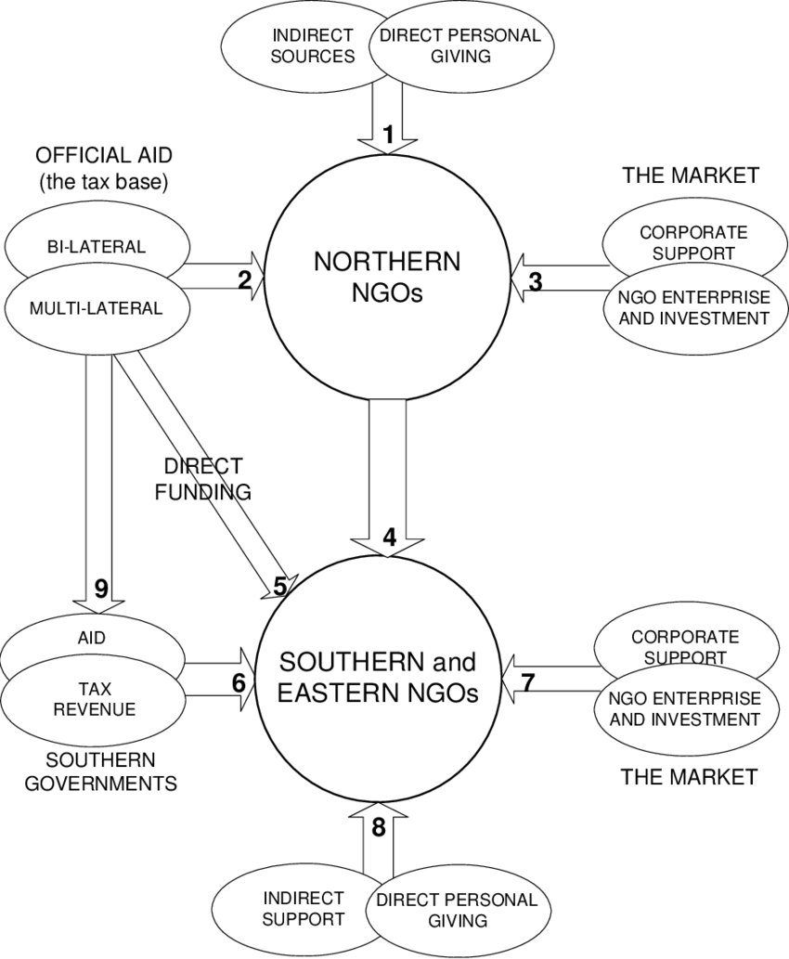

**CHAPTER 5**

**System Testing and Implementation**

**System Testing**

**Implementation**

Implementing an NGO management system using JavaScript and Vite.js involves several steps, including planning, development, testing, and deployment. Here's a high-level overview of the implementation process:

**Requirement Gathering and Planning:**

Identify the specific requirements and functionalities needed for the NGO management system, such as donor management, financial tracking, program management, reporting, etc.

Define user personas and use cases to understand how different stakeholders will interact with the system.

Create a detailed project plan outlining the scope, timeline, resources, and milestones for the implementation.

**System Design:**

Design the architecture of the NGO management system, including the frontend and backend components.

Define the data model and database schema to store information such as donor profiles, financial transactions, program details, etc.

Plan the user interface (UI) and user experience (UX) design to ensure the system is intuitive, responsive, and easy to navigate.

**Development:**

Set up the development environment using Vite.js, a modern JavaScript build tool, and framework.

Develop the frontend of the system using JavaScript frameworks/libraries such as Vue.js, React, or Angular, depending on preference and requirements.

Implement the backend logic using Node.js or other server-side frameworks like Express.js or Nest.js to handle data processing, authentication, and API integration.

Integrate third-party APIs or services for features such as payment processing, email notifications, or external data synchronization.

Implement features for user authentication, authorization, and role-based access control to ensure data security.

**Testing:**

Perform unit testing to validate the functionality of individual components and modules.

Conduct integration testing to ensure that different parts of the system work together seamlessly.

Perform user acceptance testing (UAT) with stakeholders to validate that the system meets their requirements and expectations.

Address any bugs, issues, or performance bottlenecks identified during testing.

**Deployment:**

Set up a production environment for deploying the NGO management system.

Configure hosting infrastructure using platforms such as AWS, Google Cloud, or Vercel.

Use continuous integration/continuous deployment (CI/CD) pipelines to automate the deployment process and ensure smooth updates.

Monitor system performance, security, and availability post-deployment, and implement any necessary optimizations or improvements.

**Training and Documentation:**

Provide training and documentation for users on how to use the NGO management system effectively.

Document system architecture, data flows, APIs, and development guidelines for future reference and maintenance.

**Maintenance and Support:**

Establish a maintenance plan for ongoing updates, patches, and bug fixes to keep the system secure and up to date.

Provide technical support and troubleshooting assistance to users as needed.

Collect feedback from users and stakeholders to identify areas for improvement and future enhancements.

By following these steps, you can successfully implement an NGO management system using JavaScript and Vite.js, providing NGOs with a powerful and efficient platform to manage their operations and achieve their mission goals.

**CHAPTER 6**

**CONCLUSION**

In conclusion, the implementation of an NGO management system using JavaScript and Vite.js represents a significant step forward in enhancing the operational efficiency, transparency, and impact of non-governmental organizations (NGOs). By leveraging modern web development technologies, such as Vite.js, and the versatility of JavaScript, NGOs can build a comprehensive and scalable platform to manage their diverse activities, including donor management, financial tracking, program management, reporting, and more.

The proposed system offers several key benefits, including scalability, flexibility, real-time insights, user-friendliness, and cost-effectiveness. With its integrated functionality, mobile accessibility, and emphasis on security, the system empowers NGOs to streamline their operations, engage with donors and stakeholders more effectively, and drive positive social change in their communities.

Furthermore, the adoption of an NGO management system using JavaScript and Vite.js underscores a commitment to innovation, collaboration, and continuous improvement within the NGO sector. By embracing modern development practices, open-source technologies, and community-driven approaches, NGOs can adapt to evolving challenges, seize new opportunities, and maximize their impact on a global scale.

In summary, the implementation of an NGO management system using JavaScript and Vite.js holds immense potential to revolutionize how NGOs operate, enabling them to achieve greater efficiency, transparency, and impact in pursuit of their mission to create positive change in the world.

**CHAPTER 7**

**Refernce**

**Future Enhancement**

In envisioning future enhancements for the NGO management system built with JavaScript and Vite.js, several pivotal areas emerge for potential development. First and foremost, advanced reporting and analytics functionalities could be integrated to provide NGOs with deeper insights into their operations, donor behaviors, and program impacts, thus enabling more informed decision-making. Additionally, the integration of artificial intelligence and machine learning technologies could automate tasks such as donor segmentation and fraud detection, optimizing fundraising efforts and operational efficiency. Another promising avenue lies in the exploration of blockchain technology to enhance transparency and accountability in financial transactions, grant management, and supply chain operations. Mobile application development could further expand accessibility and engagement, allowing users to access key features on their smartphones and tablets. Moreover, social media integration could facilitate donor engagement and viral campaigns, while localization and multilingual support could broaden the system's reach to diverse regions and communities. Gamification elements and rewards programs could incentivize donor participation and community involvement, fostering a culture of philanthropy and impact. Enhancements in accessibility features and continuous improvement mechanisms, coupled with robust API capabilities for seamless integration with external systems, would ensure inclusivity, usability, and adaptability to evolving needs. Through these strategic enhancements, the NGO management system using JavaScript and Vite.js can evolve into a more dynamic, versatile, and impactful platform, empowering NGOs to drive positive change and make a lasting difference in the world.